Lecturer MLOps: MLflow Intro
Course: MLOps (source: campusx YouTube lecture, per transcript)
Lecture date: [check] (not stated in transcript)
Notes prepared: 18 October 2026
Purpose: revision and later lookup

Overview
This lecture introduces MLflow for experiment tracking. It starts with a short recap of why experiment tracking matters and why the lecturer prefers MLflow over DVC for that job. It then covers MLflow's components, local setup and the UI, the difference between an experiment and a run, logging parameters, metrics, artifacts, models and tags, and finally the idea of a shared central tracking server. The lecturer runs everything locally in solo mode, and the note is explicit that the AWS server build is for a later class.
Scope: Tracking is covered in depth. The Model Registry is previewed and comes next class. Projects is mentioned only. Model serving is deferred to the deployment section, and the lecturer plans to use a different tool for it.
Focus rule from the lecturer: learn the concept of experiment tracking, not only the tool.

Section 1: Recap: Experiment Tracking and Why DVC Is Limited for It
Summary: Machine learning is trial and error, so each experiment's parameters, settings and results must be recorded to compare them later. Spreadsheets work for small teams, but larger teams need a dedicated tool. The lecturer recommends MLflow over DVC for experiment tracking.

Key concepts
- Why ML differs from ordinary software: A software project has a known target and a known build method. In ML, a goal (such as a recommendation system) can be reached many ways: different algorithms, feature engineering, and data sources. Nobody knows in advance which combination works best.
- Why tracking matters: Each trial produces an outcome. If outcomes are not stored, a new trial cannot be compared with earlier ones.
- Definition: Experiment tracking means capturing everything about each experiment (algorithm, parameters, settings, results) as it runs, so it can be reused and compared later.
- Early practice: Teams recorded runs by hand in a spreadsheet. As experiments and team members grew, this became unmanageable, which created the need for a dedicated tool.
- Expectation for industry data scientists: Domain knowledge and data science skills, plus an understanding of experiment tracking concepts, so they can work in a team.
- Tools mentioned: DVC (covered in the previous lecture), MLflow (this lecture), Comet ML, Neptune AI, and Weights & Biases. The lecturer says Weights & Biases is behind a paywall, with a free version more limited than MLflow's.

Why DVC is less suitable for experiment tracking (the lecturer's four reasons)
# | Problem | What the lecturer said | Why it matters
1 | Less intuitive workflow | DVC is tightly coupled with Git, so you must think about Git while running experiments | Extra mental load during experimentation
2 | Basic user interface | The command line output is restricted; the DVC extension is a modest improvement; plots are less clear than MLflow's | Harder to compare runs visually
3 | No central repository for teams | Each person sees only their own experiments. DVC Studio is a central option but is newer and less mature | Teammates cannot easily view each other's experiments
4 | Fewer integrations | MLflow integrates with many platforms and tools (the lecturer names Databricks, LangChain and OpenAI); DVC has fewer | Less compatibility with the wider ML stack

- Pricing point: DVC Live is free for a limited number of experiments. More runs need DVC Studio, which is paid. The point was raised by a student (Himanshu, per the transcript). MLflow is free for most of its services.
- Industry status: The lecturer says MLflow is the de facto standard for experiment tracking in most companies. DVC is used mainly for data versioning and pipelines.

Comparison: DVC vs MLflow for experiment tracking
Aspect | DVC | MLflow
Primary use (per lecturer) | Data versioning, pipelines | Experiment tracking, model management
Workflow | Tied to Git | Focused on experiments
Built-in UI | Limited (CLI; DVC extension) | Full web UI with plots and filters
Team sharing | Needs DVC Studio (paid for more runs) | Central tracking server
Integrations | Fewer | Many
Maturity (lecturer's view) | Less mature for tracking | Mature

Section questions
Covered in the Questions section below (Themes A and E).

Section 2: MLflow Introduction and Components
Summary: MLflow is an open-source platform for the end-to-end ML lifecycle. It helps data scientists and ML engineers track experiments, manage models and deploy them. It has four components. This course covers Tracking in depth, previews the Model Registry, and mentions Projects. Models (serving) comes later.

Key concepts
- Who uses it: Data scientists (for experiments) and ML engineers (for models and deployment).
- Core purposes (lecturer's words): track experiments, manage ML models, deploy models to production.
- Evolution: MLflow started with tracking and added features over time, which is common for tools.
- Generative AI and LLM features: The lecturer will not cover these recently added features, because the course focuses on machine learning.

The four components
Component | What it does (per lecturer) | Covered in this course
Tracking | Records experiments, parameters, metrics and artifacts. MLflow's original product | Yes, this lecture
Model Registry | A repository for storing models for use in deployment | Next class
Projects | Packages a project so it can be moved from one place to another | Mentioned only; the lecturer has not used it much
Models | Serves a trained model for batch or real-time prediction | Later, in the deployment section

Diagram: MLflow components by lifecycle stage
Lifecycle stage | MLflow component | Purpose
Experimentation | Tracking | Log parameters, metrics and artifacts
Model management | Model Registry | Store and version models
Packaging | Projects | Package a project for reuse
Deployment | Models | Serve models for batch or real-time use

Section questions
Covered in the Questions section below (Theme B).

Section 3: Setup and the MLflow UI
Summary: This section covers installing MLflow, launching its web UI with one command, and a first look at the Default experiment. The lecturer runs in solo mode, so only the local machine can see the data.

Key concepts
- Project setup: Create a folder named mlflow demo inside the MLOps folder and open it in VS Code. Use a terminal for all commands.
- Virtual environment: A proper project should use one. The lecturer skips it because this is a short demo.
- Installation: pip install mlflow. The lecturer already has it installed, so pip reports the requirement as satisfied. A fresh machine may take longer.
- Launching the UI: mlflow ui starts a local server and prints a local URL. Opening it shows the MLflow interface.
- Solo mode: The default when running mlflow ui this way. Only the machine that runs the command can see the data. Teammates cannot collaborate through it. A shared server is covered in Section 8.
- Two UI tabs: Experiments (all experiment logs and their details) and Models (the registry tab, covered next class).
- Default experiment: Even with no code, the UI shows an experiment named Default with ID 0. Any run not assigned to a named experiment is logged there.
- Where the data lives: Running mlflow ui created an mlruns folder. Inside it, 0/ holds the Default experiment, and its meta.yaml stores the name (default), the ID (0) and the last-updated time. The UI reads its data from these folders.

Command
mlflow ui # starts a local MLflow server and prints the URL to open in the browser

Setup steps
- Create the project folder mlflow demo and open it in VS Code.
- Open a terminal and run pip install mlflow.
- Run mlflow ui. A local server starts and prints a URL.
- Open the URL in the browser. The Experiments tab shows the Default experiment.
- On disk, the mlruns/0/ folder holds the experiment's metadata.

Section questions
Covered in the Questions section below (Themes B and E).

Section 4: Core Vocabulary: Experiment vs Run
Summary: An experiment is a set of different approaches to the same problem. A run is one execution of an experiment with specific parameter values. Planning an ML project means building a baseline first, then adding changes (feature engineering, tuning) as separate experiments, with small changes recorded as runs.

Key concepts
- Experiment (lecturer's definition): A collection of different approaches or strategies applied to one problem. Example: Random Forest on engineered features, and embeddings followed by a neural network, both aimed at predicting student placement.
- Run (lecturer's definition): One execution of an experiment with a particular set of values. Changing a parameter and running again creates a new run.
- Rule of thumb: Changing the method (Random Forest to a neural network) is a new experiment. Changing a value within the same method is a new run.
- Decision Tree vs Random Forest: Solving the same problem with a Decision Tree instead of a Random Forest creates two separate experiments.

Typical planning workflow
- Baseline model: XGBoost on the raw data, with no feature engineering or tuning. This is the reference point.
- Add feature engineering: Scaling, outlier detection and missing-value imputation on top of the baseline. Recorded as a second experiment.
- Add hyperparameter tuning: Tune XGBoost on the engineered features. Recorded as a third experiment.

- Each small change within these steps becomes a run.
- Default experiment: Any run not assigned to a named experiment goes to the Default experiment (ID 0).
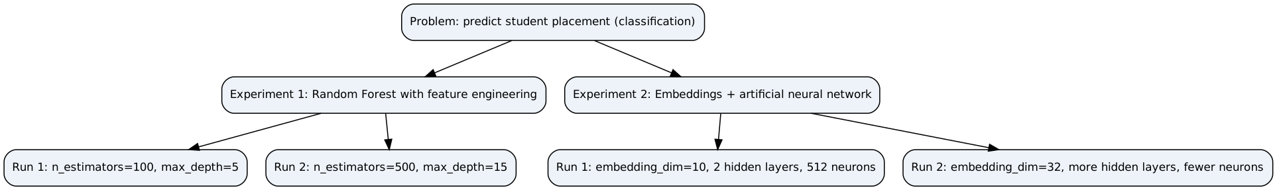
Figure 1: Experiment and run hierarchy (example from the lecture)

Section questions
Covered in the Questions section below (Theme C).

Section 5: First Tracked Run (Default Experiment)
Summary: The lecturer trains a Random Forest on the Iris dataset and logs two parameters and one metric to MLflow. He runs the script twice with different values, which creates two runs in the Default experiment. The section also covers how runs appear in the UI, how they are stored on disk, and how run names are generated.

Key concepts
- Training script: Loads Iris, splits train and test, trains a Random Forest classifier, predicts on the test set and computes accuracy. Logging is added around this code.
- Context manager: with mlflow.start_run(): opens a run and closes it when the block ends, so end_run() is not needed. The lecturer calls it the standard pattern now.
- Logging functions used: log_param records hyperparameters (max_depth, n_estimators). log_metric records a numeric result (accuracy).
- No experiment name in the code, so runs go to the Default experiment (ID 0).
- Run 1: max_depth = 5, n_estimators = 100. Accuracy shown as 100%.
- Run 2: max_depth = 15, n_estimators reduced. The lecturer says this run is faster (about 94 ms) because fewer estimators are trained.
- Failed runs are recorded too: An earlier attempt that raised an error also appears, and can be deleted from the UI.
- Run details in the UI: run name, run ID, experiment name and ID, creation time, user, status (FINISHED), duration, source file, logged parameters and metrics. Dataset is blank because none was tracked. Artifacts and model are empty at this stage.
- Auto-generated run names: Given no name, MLflow generates one, such as polite_flea.
- Run ID vs experiment ID: Each run has its own ID, separate from the experiment ID. The lecturer shows run IDs ending in 64A8 and 2d73.
- Storage on disk: Each run has its own folder under mlruns/0/, with a meta.yaml. The UI reads from these folders.
- Deleting runs: Deleting a run in the UI hides it, and the lecturer says the backend keeps the data. Removing the run's folder from mlruns makes it disappear from the UI, so the folder is the real data source.
- Export: The UI has an export option for run data.
- Unused import: mlflow.sklearn is imported but not used yet. It is used when a model is logged (Section 7).

Code excerpt (key lines; names reconstructed from the spoken transcript)
with mlflow.start_run(): # open a run; closes automatically at block end
rf = RandomForestClassifier(max_depth=5, # set hyperparameters
n_estimators=100)
rf.fit(X_train, y_train) # train the model
y_pred = rf.predict(X_test) # predict on the test set
accuracy = accuracy_score(y_test, y_pred) # compute accuracy

mlflow.log_metric("accuracy", accuracy) # record the result
mlflow.log_param("max_depth", max_depth) # record hyperparameter
mlflow.log_param("n_estimators", n_estimators)

Flow of one tracked run
Figure 2: Lifecycle of one tracked run

Section questions
Covered in the Questions section below (Themes C and E).

Section 6: Custom Experiments and Naming
Summary: Instead of logging to the Default experiment, the lecturer creates a named experiment iris-dt and points a new script at it. He shows two ways to choose an experiment, explains why experiment IDs are large numbers, and shows how to set a custom run name.

Key concepts
- Creating an experiment: Through the UI (click plus on the Experiments tab, enter a name, keep the default artifact location), or through code with mlflow.create_experiment() (mentioned, not used).
- Routing a run to an experiment: mlflow.set_experiment("iris-dt") selects by name and creates the experiment if missing. Passing experiment_id to start_run() selects by ID. The lecturer uses the name method.
- Why IDs are large numbers (lecturer's explanation): To avoid clashes when several people log to one central server. Two users on separate machines could otherwise both get ID 1. The Default experiment keeps 0.
- Second experiment: In the lecturer's example it has ID 54484, with its own folder in mlruns/ and its first run 2d73.
- Same dataset, different model: The script is copied, RandomForestClassifier is replaced by DecisionTreeClassifier, and n_estimators is removed. Only max_depth is still logged.
- Forgotten save: The lecturer forgets to save the file, so the run lands in the Default experiment. He notices, saves and reruns.
- Custom run names: run_name in start_run() replaces the generated name. The example is campusx experiment.

Code excerpt
mlflow.set_experiment("iris-dt") # select (or create) the experiment by name

with mlflow.start_run(run_name="campusx experiment"): # custom run name
dt = DecisionTreeClassifier(max_depth=5) # decision tree instead of random forest
dt.fit(X_train, y_train)
y_pred = dt.predict(X_test)
accuracy = accuracy_score(y_test, y_pred)

mlflow.log_metric("accuracy", accuracy) # record accuracy
mlflow.log_param("max_depth", 5) # record hyperparameter

Section questions
Covered in the Questions section below (Theme C).

Section 7: Logging Artifacts, Code, Models, and Tags
Summary: Beyond parameters and metrics, MLflow can store files (artifacts) with each run: plots, source code and trained models. Logging artifacts fails in solo mode with a file-based URI, so the lecturer starts a local HTTP tracking server as a workaround. He also shows how to add tags and search by them.

What can be tracked (lecturer's list)
- Parameters: hyperparameters and other function arguments, such as a random state.
- Metrics and losses.
- Artifacts: any related file, such as plots, data files, source code and models.
- Environment details: Python version, pip version, installed libraries.
- Automatic metadata: run name and ID, experiment name and ID, author, creation and update times.
- Custom tags: free-form key-value labels for search.

Plots as artifacts
- A confusion matrix is drawn as a seaborn heatmap, saved as confusion_matrix.png in the project root, and logged with mlflow.log_artifact(). The lecturer notes that log_image() also exists but does not use it.

The file-URI error and workaround
- Error: In solo mode, artifact logging fails. The error says the tracking URI scheme file is invalid for proxy MLflow artifact logging. The lecturer says artifacts can only be logged over HTTP or HTTPS.
- Workaround: mlflow.set_tracking_uri("http://127.0.0.1:5000"), or the URL printed by the local server, at the top of the script. Parameters, metrics and artifacts then appear in the UI as before. The lecturer calls this a local stand-in for a real server.
- Check the current URI: mlflow.get_tracking_uri() prints it.

Logging source code
- mlflow.log_artifact(__file__) stores the current script with the run, so the exact code that produced it is saved. Git normally handles this, but the artifact copy works without Git.

Logging a model
- mlflow.sklearn.log_model(dt, "decision_tree") stores the trained model. The scikit-learn-specific function is preferred over the generic log_model because it records more metadata, including how to serve the model with pandas or Spark DataFrames.
- Files produced: model.pkl (serialised model), MLmodel (metadata), conda.yaml (environment) and requirements.txt (libraries). MLflow collects environment details automatically.
- The model can be registered in the Model Registry, covered next class.

Tags
- mlflow.set_tag(key, value) adds a searchable label. The lecturer sets an author tag and a model-type tag (decision tree). Tags can also be added in the UI.
- Searching by tag: The UI search bar filters runs by tag (the lecturer types a tags.author filter). This matters when a project has hundreds of runs.

Code excerpt
import mlflow
mlflow.set_tracking_uri("http://127.0.0.1:5000") # HTTP tracking server so artifacts can be logged

with mlflow.start_run():
# ... training and metric code as in Section 6 ...
mlflow.log_artifact("confusion_matrix.png") # store the saved plot
mlflow.log_artifact(__file__) # store this script
mlflow.sklearn.log_model(dt, "decision_tree") # store the model with environment info
mlflow.set_tag("author", "nitesh") # searchable label
mlflow.set_tag("model", "decision tree")

Flow for an artifact-enabled run
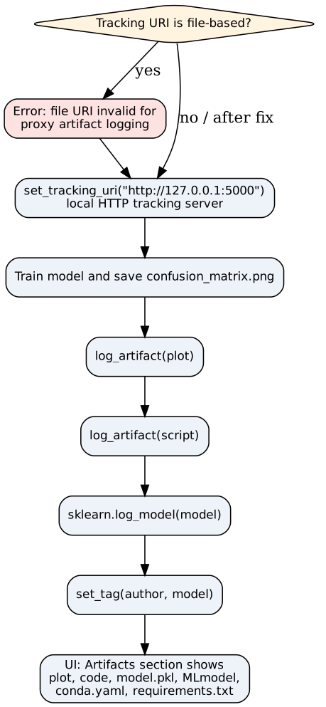
Figure 3: Artifact logging path and the file-URI workaround

Section questions
Covered in the Questions section below (Theme D).

Section 8: Remote Tracking Architecture (Conceptual)
Summary: Solo mode stores everything on one machine, so teammates cannot see runs. A shared setup puts a tracking server in a central location. Metadata goes to a database, and large files go to cloud storage. Every member's code sends data to that one server. The lecturer explains the design now and will build it on AWS in a later class.

Key concepts
- Why a central server: In solo mode, data lives in your local mlruns folder. A team needs one place where every member's runs are visible and comparable.
- Client (you): Your code calls the tracking APIs (start_run, log_param, log_metric, log_artifact).
- Tracking server: A central MLflow server. Every member points their code at its URL.
- Metadata store: A database for parameters, metrics, tags and run information. The lecturer names RDS or MySQL as examples.
- Artifact store: Cloud storage for plots, models (.pkl) and source code. The lecturer names AWS S3 as the example.
- Two types of data, two destinations: Metadata is small and searchable, so it goes to the database. Artifacts can be large, so they go to object storage.
- Scalability (lecturer's view): The database grows with metadata and object storage grows with artifacts. Neither depends on one laptop.
- Link to Section 7: The local HTTP server used as a workaround is a small version of this design, with no shared database or cloud storage.
- What changes for a real deployment: Mainly the tracking URI, which points to the AWS server instead of 127.0.0.1.

Diagram: central tracking architecture
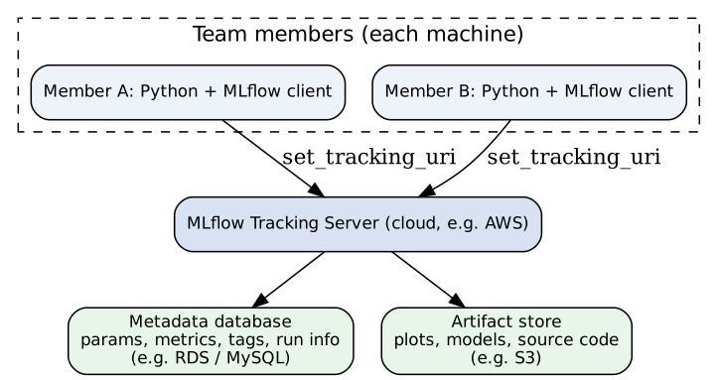
Figure 4: Central tracking server with metadata database and artifact store

Solo mode vs central server
Aspect | Solo mode (this lecture) | Central tracking server (lecturer's design)
Where runs are stored | Local mlruns folder | Metadata database plus cloud storage
Who can view runs | Only the machine that ran mlflow ui | Every team member with the URL
Artifact logging | Blocked in the lecturer's version (file-URI error) | Allowed over HTTP or HTTPS
Code change | None | Set tracking URI to the server address
Scalability (lecturer's view) | Single machine | Designed to scale with data

Section questions
Covered in the Questions section below (Theme E).

Master Flowchart
The full lecture as a single flow, from the recap to the next class.
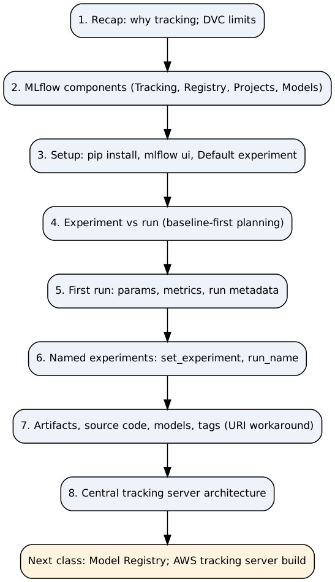
Figure 5: Master flowchart of the lecture

Glossary
Term | Definition | Section
Artifact | Any file stored with a run, such as a plot, source code or model | 7
Artifact store | Storage for large files on a central server (S3 in the lecturer's example) | 8
Baseline model | The first, simplest model (XGBoost on raw data in the lecture) used as a reference | 4
Context manager | Python with block; here it opens a run and closes it automatically | 5
Default experiment | Experiment with ID 0; receives runs that name no experiment | 3
DVC | Data version control tool, used mainly for data versioning and pipelines | 1
DVC Studio | DVC's central, paid option for team experiment views (per transcript) | 1
Experiment | A set of different approaches or strategies applied to one problem | 4
Experiment ID | Numeric ID of an experiment; large numbers chosen to avoid clashes (lecturer's explanation) | 6
Feature engineering | Creating or transforming input features (e.g. scaling, PCA, imputation) | 4
Hyperparameter | A model setting chosen before training, such as max_depth or n_estimators | 5
Hyperparameter tuning | Searching for better hyperparameter values for a model | 4
Metadata store | Database holding parameters, metrics, tags and run information (RDS/MySQL in the example) | 8
Metric | A numeric result logged for a run, such as accuracy | 5
Model Registry | A repository of models for use in deployment; covered next class | 2
Parameter | An input value logged for a run (log_param) | 5
Run | One execution of an experiment with specific values | 4
Run ID | Unique ID of a run, separate from the experiment ID | 5
Run name | Readable name for a run; auto-generated (e.g. polite_flea) or set with run_name | 5
Solo mode | Local-only use of mlflow ui; only the local machine can see the data | 3
Tag | A searchable key-value label on a run (set_tag) | 7
Tracking server | Central MLflow server that teammates' code sends data to | 8
Tracking URI | Address MLflow sends data to; a file path in solo mode, or an HTTP address for a server | 7
mlruns | Folder where local tracking data is stored (named ML runs in the transcript) | 3
meta.yaml | Metadata file in each experiment and run folder | 3
MLmodel | Metadata file describing a logged model | 7
model.pkl | Serialised model file produced by log_model | 7
conda.yaml | Environment file for a logged model (spelled out in the transcript as a garbled term) | 7
requirements.txt | List of libraries for a logged model | 7
set_experiment | Selects an experiment by name, creating it if missing | 6
start_run | Opens a run, with optional run_name and experiment_id | 5
log_param / log_metric | Record a parameter or a metric for the current run | 5
log_artifact | Store a file with the current run | 7
set_tag | Add a tag to the current run | 7

Questions
Grouped by theme, with duplicates merged. Each question is open; the lecture does not answer them.

Theme A: Why track, and which tool
- The lecturer says tools change and DVC could improve within two years. What would be a fair way to test that claim before choosing a tool?
- Does DVC Studio solve the team-sharing problem, or does it still leave a gap? The transcript does not say.
- How does tracking differ from saving files? Which parts of an experiment are needed to reproduce a result?

Theme B: MLflow components and setup
- The lecturer lists four components but says the course reads two. Which two, and why were these chosen?
- Projects is listed as a component, but the lecturer has not used it much. How important is it for a beginner, compared with Tracking and the Registry?
- If the course uses a different tool for model serving, how will the Models component fit into the workflow?
- The lecturer skips the virtual environment for this demo. What could go wrong if MLflow is installed into the global Python environment for a real project?

Theme C: Experiments, runs and naming
- If you change both the algorithm and a parameter at the same time, is that one experiment or two, and how should it be recorded?
- Why does the lecturer start with a baseline? What would you lose by skipping it?
- Does a single experiment need one family of methods, or can it mix them (for example, embeddings with a classical model)?
- Auto-generated run names save effort, but what are the risks? When would you set your own name with run_name?
- If two runs both show 100% accuracy, how would you decide which is better (for example, speed versus accuracy)?
- The lecturer says large experiment IDs prevent clashes on a shared server. Are there other reasons for this ID scheme? What if two experiments share a name?
- set_experiment creates an experiment when the name is missing. What is the risk when someone mistypes a name, such as iris-dt versus iris_dt?
- In a team project, would you use set_experiment or experiment_id, and why?

Theme D: Artifacts, code and models
- The lecturer says artifacts are blocked in solo mode and allowed only over HTTP. Is a local HTTP server a real tracking setup or only a demo workaround? What would change in production?
- The confusion matrix PNG is deleted from the project folder after logging. Is that safe? Does MLflow store a copy or a link to the file?
- The lecturer says logging the script is a substitute for Git. What does Git record that the artifact copy does not?

Theme E: Team use and remote servers
- How does a teammate see your runs? Does DVC Studio fully solve it, and what does solo mode prevent?
- The lecturer separates metadata from artifacts. What would go wrong if both were stored in one database?
- If the tracking server goes down, does a team member's running experiment stop, or fail only when logging?
- Who should be allowed to delete runs on a shared server, and how would you control that? Deleting a run in the UI hides it but may not remove the data.

Summary
- ML is trial and error. Experiment tracking records each run's parameters, metrics and artifacts so runs can be compared later.
- The lecturer prefers MLflow over DVC for experiment tracking, citing workflow, UI, team sharing and integrations.
- MLflow has four components. This course covers Tracking now, the Model Registry next class, and treats Projects and Models lightly.
- An experiment is a set of approaches to one problem. A run is one execution with specific values.
- Runs without a named experiment go to the Default experiment (ID 0). set_experiment selects or creates an experiment by name.
- start_run opens a run with a context manager. log_param, log_metric, log_artifact, log_model and set_tag record its contents.
- In the lecturer's solo setup, artifact logging fails with a file-based URI. The workaround is a local HTTP tracking server.
- A central tracking server stores metadata in a database and artifacts in cloud storage. The only code change is the tracking URI.
- Plan experiments baseline-first: baseline, then feature engineering, then hyperparameter tuning.
- Next class: the Model Registry, and a comparison example. The AWS tracking server build follows later.

Items to Verify
Every [check] and [unclear] marker from the section notes, listed in one place. [check] means confirm the value or spelling. [unclear] means the transcript does not settle it.
# | Item | Flag | Section | Note
1 | "DVC Live" spelling (written in Devanagari in the transcript) | [check] | 1 | Confirm the exact name
2 | "Pranjal" spelling (another instructor the lecturer recommends) | [check] | 1 | Confirm spelling
3 | Himanshu raised the paid-tier point | [unclear] | 1 | Transcript does not say whether the lecturer checked it
4 | DVC Studio pricing and limits | [unclear] | 1 | Lecturer says he has not used it; current limits not confirmed
5 | Alternative name for the Models component | [unclear] | 2 | Lecturer says the team calls it something else; name not given
6 | Models tab in the UI vs the Models component | [check] | 2 | Confirm they match
7 | Description of Projects ("move from one place to another") | [check] | 2 | Confirm against MLflow docs
8 | Port number of local server | [check] | 3 | Usual default is 5000; confirm the URL printed on your machine
9 | Whether the background UI process stays running after the terminal closes | [unclear] | 3 | Not stated
10 | MLflow version (2.14, which the lecturer believes is old) | [check] | 3, 7 | Matters for the file-URI error
11 | Unnamed configuration setting the lecturer suspects | [unclear] | 3, 7 | Not named in transcript
12 | Embedding and hidden-layer values in the second experiment | [unclear] | 4 | The number of hidden layers is not stated
13 | Random Forest vs Decision Tree example, and Iris code | [check] | 4, 5 | Confirm the switch is intentional
14 | Accuracy 100% for both runs | [check] | 5 | Confirm on your own run
15 | Second run's n_estimators value (spoken as 10) | [check] | 5 | Transcript suggests 10
16 | Variable names in code excerpts are reconstructed | [check] | 5, 6, 7 | Confirm against the actual script
17 | Whether the UI or the file system is authoritative for deleted runs | [unclear] | 5 | Lecturer's interpretation; not settled
18 | "Defined bug 839" fragment | [check] | 5 | Likely a transcription error for the auto-generated run name
19 | mlflow.sklearn spelled as "MLflow.skl", "skln" and "scln" | [check] | 5, 7 | Corrected here; confirm course spelling
20 | Experiment ID 54484 (read quickly) | [check] | 6 | Confirm on your machine
21 | max_depth in the Decision Tree code | [unclear] | 6 | Spoken value is unclear; 5 is used for consistency
22 | Large-ID explanation (clash avoidance) | [check] | 6 | Lecturer's explanation, not a documented rule; confirm
23 | File-URI error: whether version-specific | [unclear] | 7 | Test with mlflow.get_tracking_uri() on your version
24 | Port in the HTTP workaround | [check] | 7 | Confirm the exact port
25 | Garbled function names ("log pram", "get tracking URI") | [check] | 7 | Corrected to log_param and get_tracking_uri
26 | Environment file spelled as a garbled term in transcript | [check] | 7 | Corrected to conda.yaml; confirm in artifacts
27 | Tag filter syntax (tags.author) | [check] | 7 | Typed, not clearly shown; confirm for your MLflow version
28 | Author tag value "nitesh" | [unclear] | 7 | Possibly the lecturer's name or a placeholder
29 | Artifact path shown in the UI | [unclear] | 7 | Depends on storage location; not confirmed
30 | Database example (RDS / MySQL) | [check] | 8 | Confirm the database used in the AWS class
31 | Artifact store example (S3) | [check] | 8 | Confirm in the AWS class
32 | Whether the 127.0.0.1 workaround would work for a real team on one network | [unclear] | 8 | Not stated

